Session 01

Exercise 01

Consider the diagram below. Link 1 has length L1 m (where m stands for meters) and allows packets to be propagated at speed S1 (m/s) , while Link 2 has length L2 m but it only allows packets to be propagated at speed S2 (m/s) (because two links are made of different materials). Link 1 has transmission rate T1 (bits/s) and Link 2 has transmission rate T2 (bits/s).



Assuming nodes can send and receive bits at full rate and ignoring processing delay, consider the following scenarios:

1. How long would it take to send a packet of 500 Bytes from Node A to Node B given T1 = 10000, L1 = 100000, and S1 = 2.5 ・ 108?

Solution: The total time needed is the sum of the transmission delay to push the packet onto Link 1 and the propagation delay for the packet to travel from Node A to Node B.

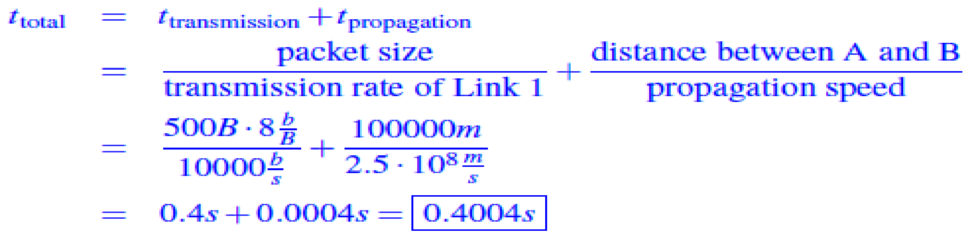

Notice that transmission delay dominates more than 99.9% in this case.

1. Compute RTT (round trip time) for a packet of B Bytes sent from Node A to Node C (packet gets transmitted back from Node C immediately after Node C receives it).

Solution: There is only one packet so no need to worry about queuing delays. Consider the diagram

below:

Note the sequence of delays the packet experiences during its route from A to C:

1. Transmission delay to push the packet onto Link 1.

2. Propagation delay as the packet travels from Node A to Node B.

3. Transmission delay to push the packet onto Link 2.

4. Propagation delay as the packet travels from Node B to Node C.

5. Transmission delay to push the packet onto Link 2.

6. Propagation delay as the packet travels from Node C to Node B.

7. Transmission delay to push the packet onto Link 1.

8. Propagation delay as the packet travels from Node B to Node A.

Summing these delays yields the total RTT:



At time 0, Node A sends packet P1 with D1 Bytes and then it sends another packet P2 with D2 Bytes

immediately after it pushes all bits of P1 onto Link 1. When will Node C receive the last bit of P2?

Solution: There are two packets, and so we might need to consider queueing delays. There will be a

queueing delay at Node B if P2 arrives at B before P1 is finished being pushed onto Link 2.

Let’s start by computing the time at which P1 finishes being pushed onto Link 2. P1 takes 8D1/T1

Seconds to be pushed onto Link 1, L1/S1 seconds to propagate from Node A to Node B, and then 8D1/T2 seconds to be pushed onto Link 2. Hence P1 leaves Node B at time

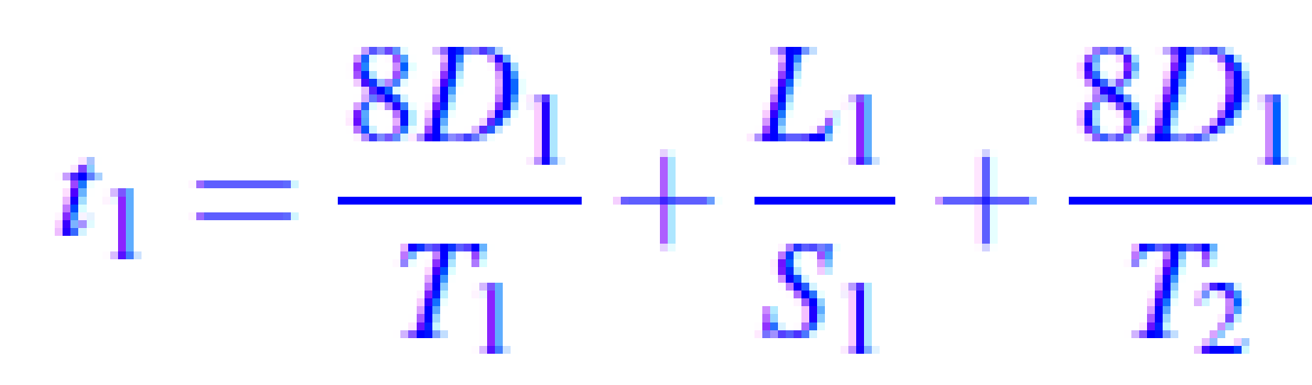

Next, let’s figure out the time when P2 arrives at Node B. It first waits 8D1/T1 seconds for P1 to be completely pushed onto Link 1, then takes 8D2/T1 seconds of transmission delay to be pushed onto Link 1 itself, before finally needing L1/S1 seconds of propagation delay to reach Node B. With this, we know that P2 reaches Node B at time

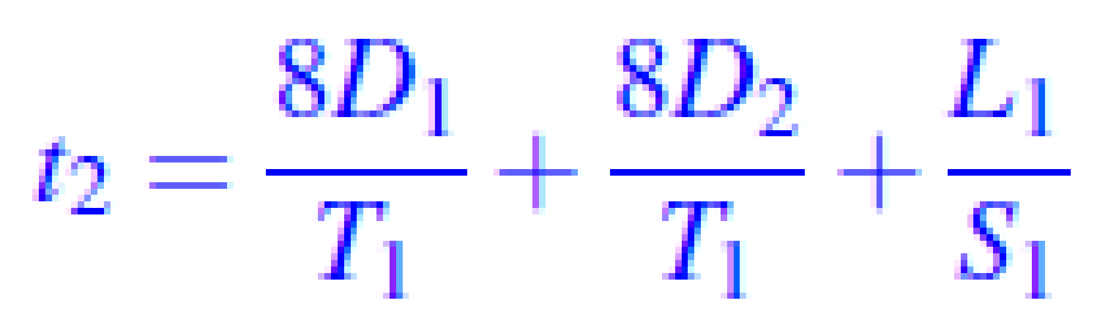

There’s queueing delay if t1 > t2, and the length of the delay can be expressed as

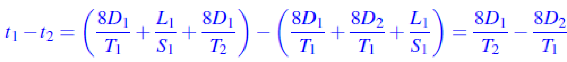

With this analysis in hand, we can express the time at which NodeC receives the last bit of P2 as follows:

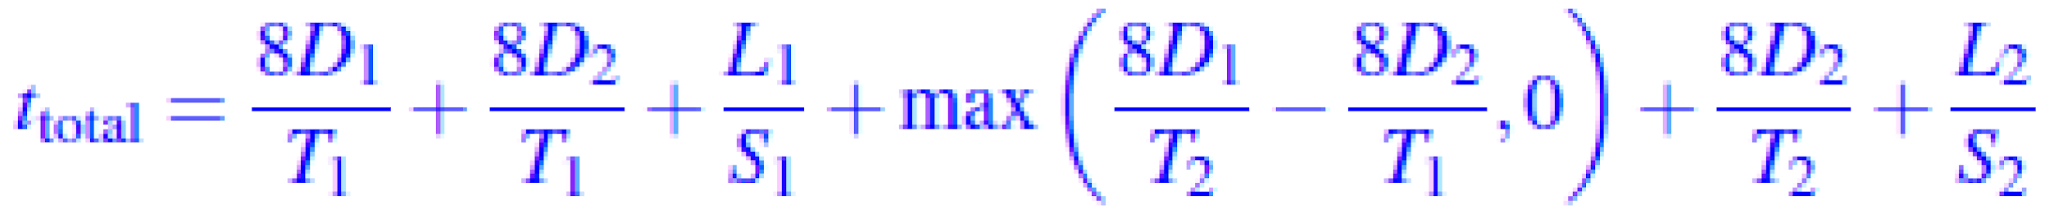

From left to right, the terms in this sum are:

1. The transmission delay to push P1 onto Link 1.

2. The transmission delay to push P2 onto Link 1.

3. The propagation delay as P2 travels from Node A to Node B.

4. The queueing delay at Node B. Note that the use of the max operator allows us to express the two

cases when there is and when there isn’t queueing delay compactly.

5. The transmission delay to push P2 onto Link 2.

6. The propagation delay as P2 travels from Node B to Node C.

Below is the time-graph of a packet in flight without queuing delay:

At time 0, Node A sends packet P1 with D1 Bytes and then it sends another packet P2 with D2 Bytes

immediately after it pushes all bits of P1 onto Link 1. When will Node C receive the last bit of P2?

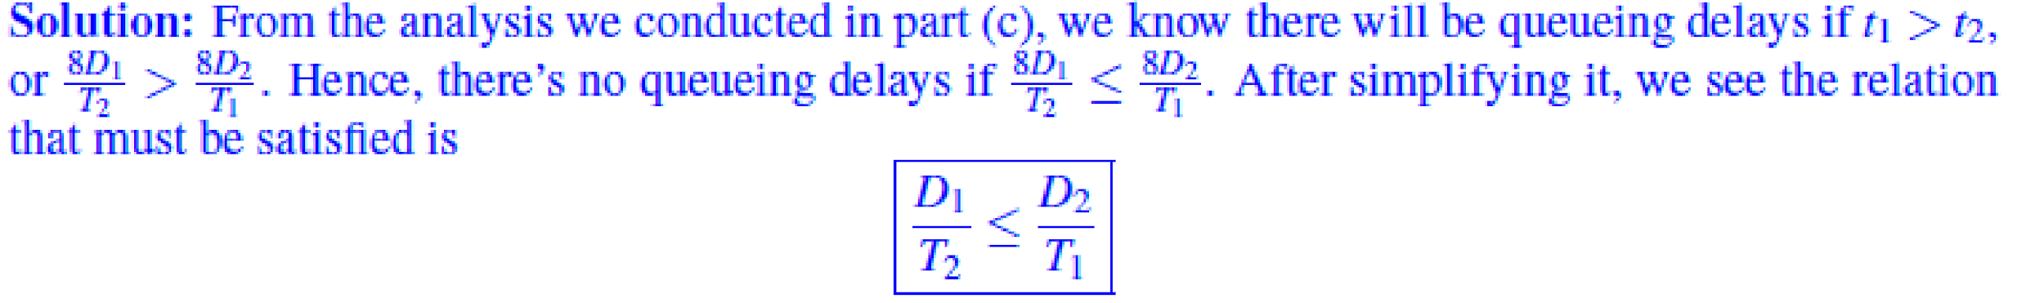

Exercise 02:

Consider a single link with bandwidth B and propagation delay L. It takes 1 msec for an entire 500 bytes packet to arrive at the other end of the link (that is, it takes 1 msec from the time the first bit starts being transmitted until the last bit arrives at the other end of the link). It takes 2 msec for an entire 1500 bytes packet to arrive at the other end of the link.

What is the bandwidth B of the link? (in Mbps)

What is the propagation delay L of the link? (in msec)

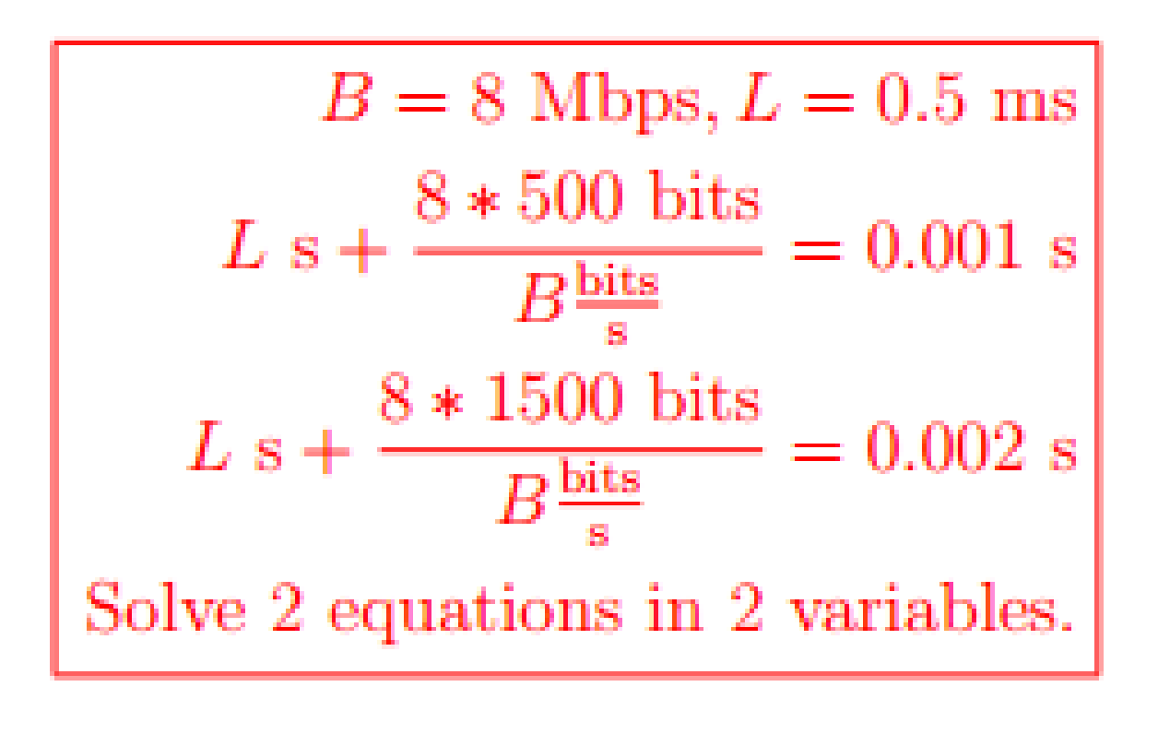

Exercise 03

Let us consider a simple packet-switching system as shown in the figure below.

* The path from sender A to receiver B passes through two intermediate routers.
* Each router has an input queue of size 1 [Mbit].
* The three links support the same data rate R=10 [kbps].

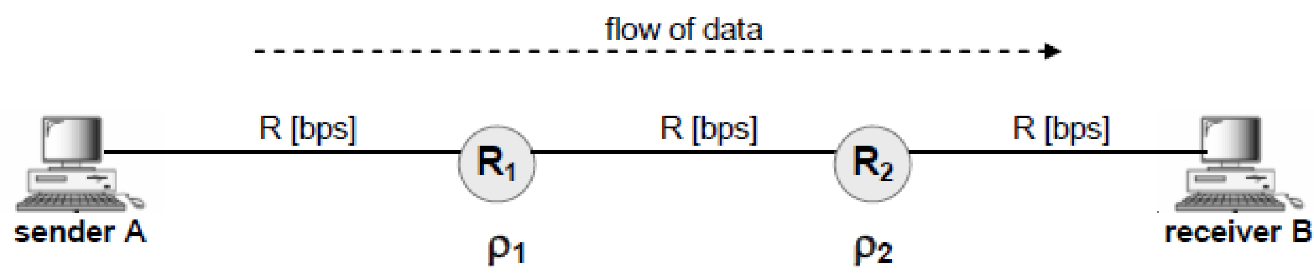

Assume the utilization of the first router (R1) is ρ1 = 0.2, the utilization of the second router is ρ2 = 0.3, and sender A generates and sends one packet of size 10 [kbit] every 3 seconds. What is the rate at which packets arrive at receiver B?

arrival rate to R1 = departure rate from A

arrival rate to R2 = departure rate from R1

arrival rate to B = departure rate from R2

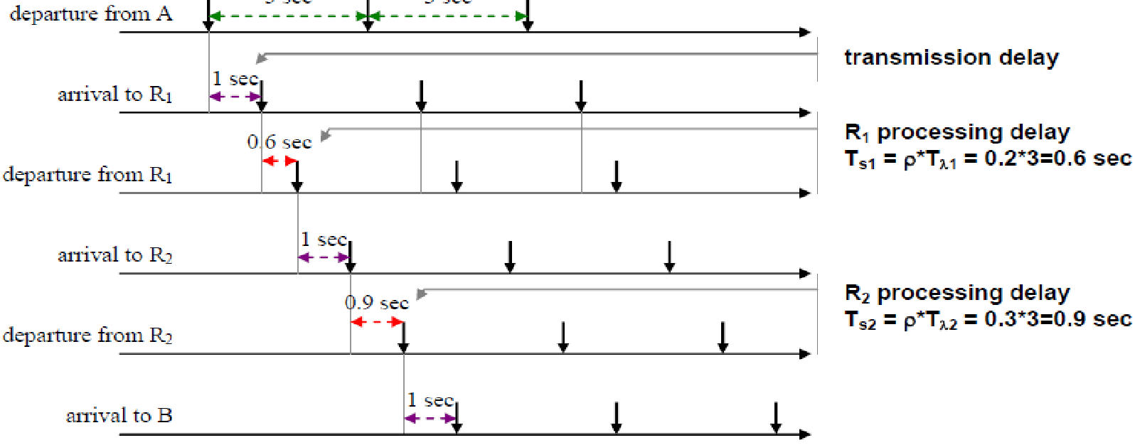

The arrival rate to B is the same as the departure rate from A = 1/3 [packet/sec] or A = 3.33 [kbit/sec].

The assumptions remain the same as in (a); except, sender A generates and sends only 3 packets in total. What is the overall time required to deliver these three packets to receiver B? (Propagation delay can be ignored on all three links.)

Based on the above picture, the overall delay = 6 [sec] + time to deliver last packet Time do deliver last packet = dtrans.(A,R1) + dproc.(R1) + dtrans.(R1,R2) + dproc.(R2) + dtrans.(R2,B) = 1 sec + 0.6 sec + 1 sec + 0.9 sec + 1 sec = 4.5 [sec]

**overall delay = 10.5 [sec]**

(c) The assumptions are the same as in (a); except, the utilization of the second router (R2) changes to ρ2 = 1.2. What is the rate at which packets arrive at receiver B in this case?

In this case, R2 is clearly a ‘bottleneck’ – its slow processing (i.e. its long service time of Ts2 = 1.2*3 [sec] = 3.6 [sec]) dictates the packet departure rate, i.e. the packet arrival rate at B.

**Hence, arrival rate at B = 1/Ts2 = 1/3.6 [packets/sec] = 2.7 [kbit/sec]**

(d) The assumptions remain the same as in (c). What are the maximum size to which queues in routers R1 and R2 grow? (Answer for each queue individually.)

R1: Based on the above picture, it is clear that packets always arrive to ‘idle’ R1. This, and ρ1 = 0.2, suggest that the size of R1 queue remains 0 at all times.

R2: ρ2 = 1.2 suggests that R2 is over-utilized. Accordingly, we conclude - the size of R2 queue will keep growing until reaches its maximum. After that point, newly arrived packets will have to be dropped.

Exercise 04

Suppose we would like to transfer a file of K bits from node A to node C using packet switching (see Figure 2.1). The path from node A to node C passes through two links and one intermediate node, B, which is a store-and-forward device. The two links are of rate R [bps]. The packets contain P bits of data (P<K) and a 6 byte header.

What value of P minimizes the time it takes to transfer the file from A to C? (You can assume: propagation delay on each link = 0, and K/P gives an integer number.)

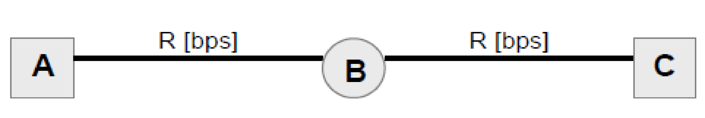

# of packets to transmit the file: K/P packets

Transmission time per each packet:





Overall transmission time:

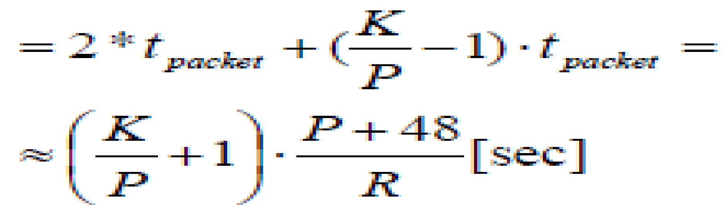

Taking the first derivative of ttotal with respect to packet size P, we obtain:



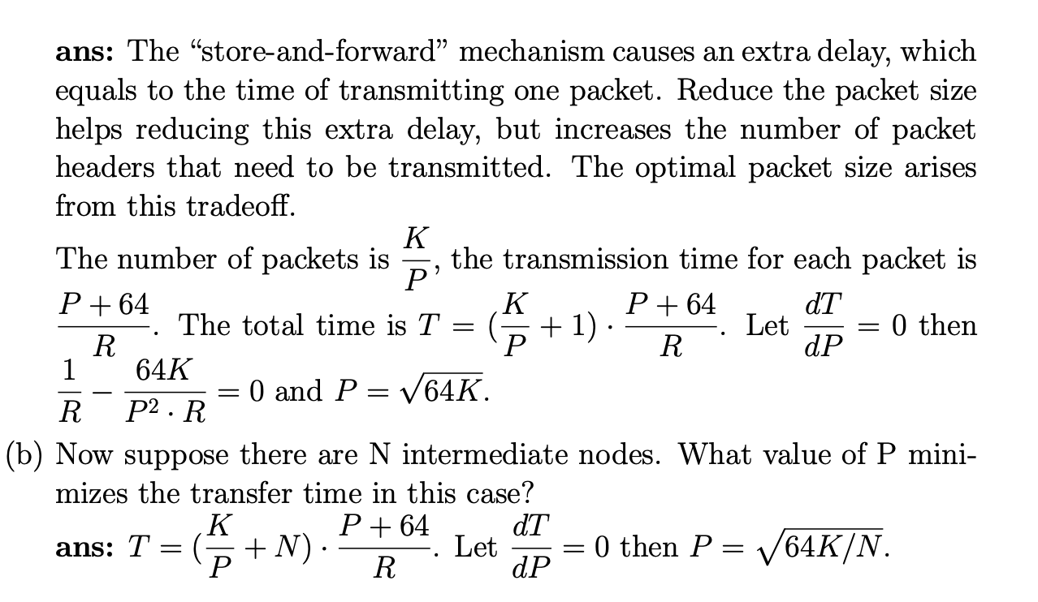

Exercise 05

Assume there is one router and two links between the file server and client, as shown in the figure below. The first link has transmission rate R1 and the second link has transmission rate R2. Assume the file gets broken into three packets, each of size L. Ignore all propagation and processing delays. Answer the following three questions:

(a) How long does it take from when the server starts sending the file until the client has received the whole file if R1 ≤ R2?

(b) How long does it take from when the server starts sending the file until the client has received the whole file if R1 > R2?

(c) In case (b), how long does the second packet spend in the router’s queue?

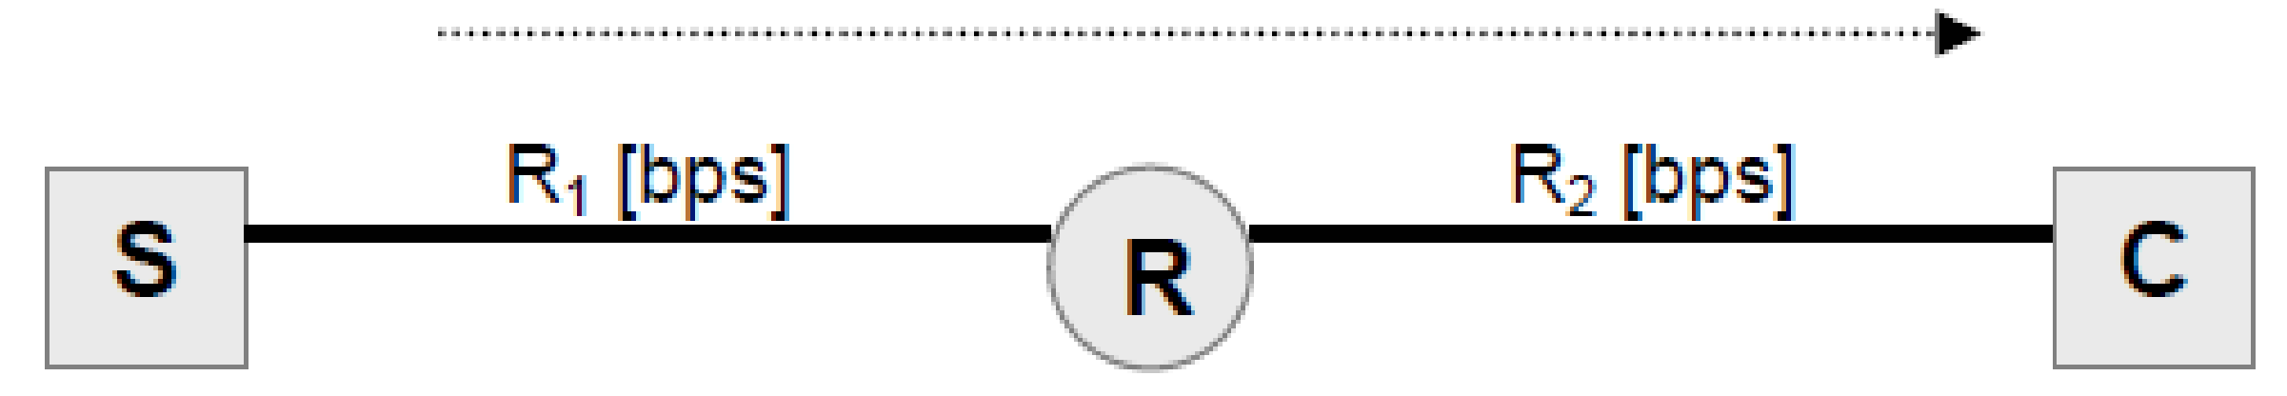

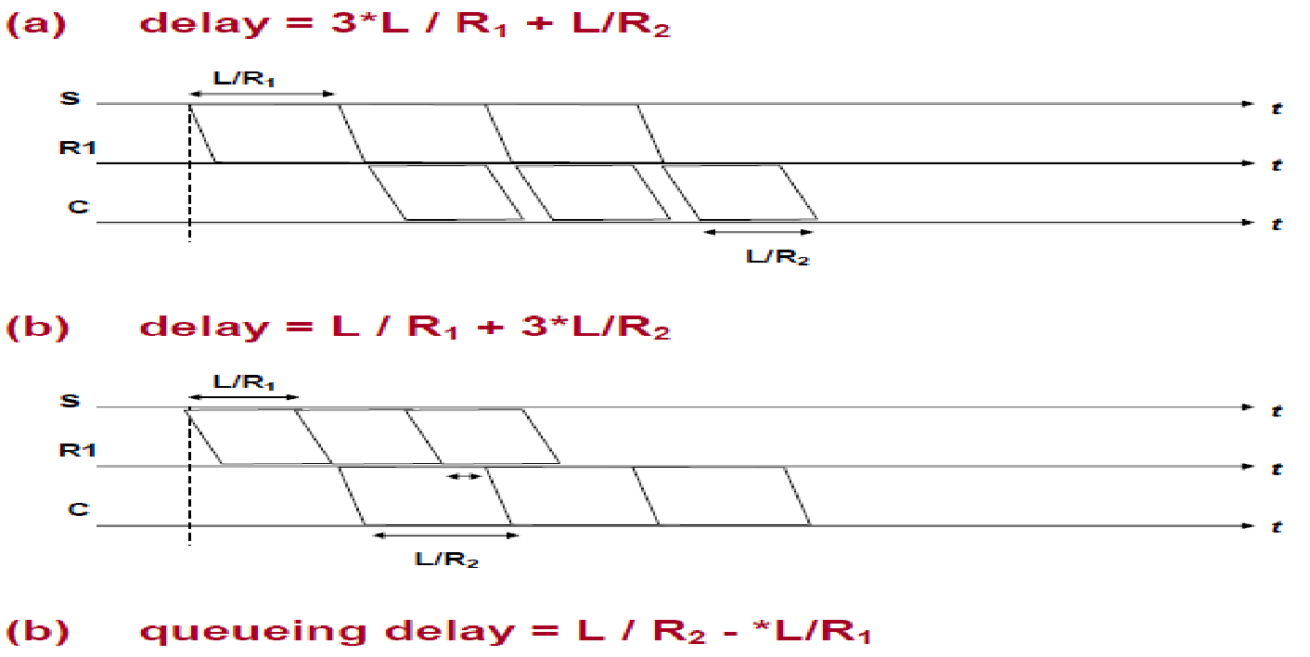

Exercise 06

Consider two serially connected packet switches as shown in the figure below. The link connecting the two switches (*Link 1*) is full-duplex, with datarate of 1 Mbps and propagation delay of 3 ms (in each direction). The packets sent through the network are 1000 bits long. The input buffer/queue of Switch 2 can store at most 100 packets.

To control congestion and avoid packet loss, the switches employ the so-called ‘back pressure’ mechanism. According to this mechanism, whenever Switch 2 detects congestion on its outgoing link (i.e., no more packets can be sent over *Link 2*), Switch 2 sends a signal back to Switch 1 instructing Switch 1 to halt further packet transmission over *Link 1*.

In this question, you are asked to determine how big Switch 2 should let its buffer grow (in case of congestion on *Link 2*), before sending a back pressure signal to Switch 1. Your answer should be in the units of ‘packets’.

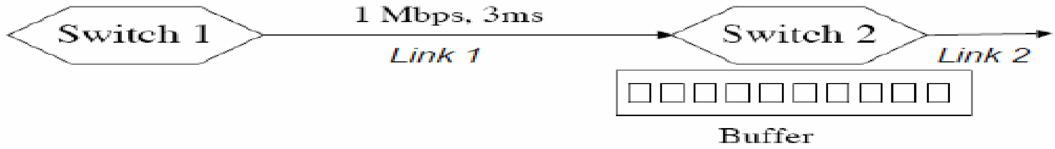

Additional assumptions:

• There is an unlimited number of packets at Switch 1; therefore, when active, Switch 1 sends packet continuously, back-to-back.

• Once detected, the congestion on *Link 2* could be alleviated at any point in time. Hence, the back pressure signal should not be sent too early (unless there is a real risk of Switch 2 running out of buffer space), nor too late (no packet should ever be lost/dropped).

**SOLUTION:**

Let us first assume that Switch 2 waits for its buffer to get 100% full before sending the back pressure signal to Switch 1. In this case, all those packets already in transit as well those generated by Switch 1 within the time it takes for the back pressure signal to arrive to Switch 1, will be lost.

The actual number of such (lost) packet would be:

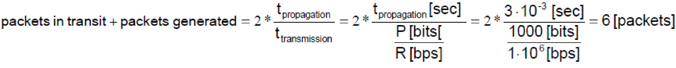

Thus, to prevent packet loss, yet allow its buffer to grow to maximally allowable size, Switch 2 needs to send the back pressure signal at the time when it has just enough space to absorb the packets that will be in transit or generated during the time the back pressure signal is propagating back to Switch 1.

Accordingly, Switch 2 should let is buffer grow to the size of 94.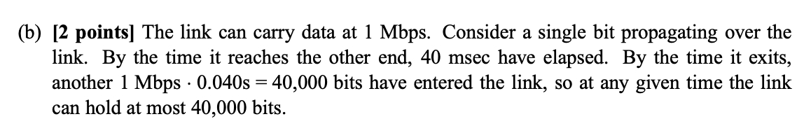

**Karim**: the above may help understand the solution

Exercise 07

Cut-through Switching

Unlike store-and-forward, cut-through switching or forwarding allows a node inside a network to start forwarding a packet before it has been received in its entirety. Consider a path in a network that connects a host “Src” to a host “Dst” via n links (1..n) through n-1 intermediate routers, each employing cut-through forwarding.

Ignore processing delay and assume that there is no queuing delay. 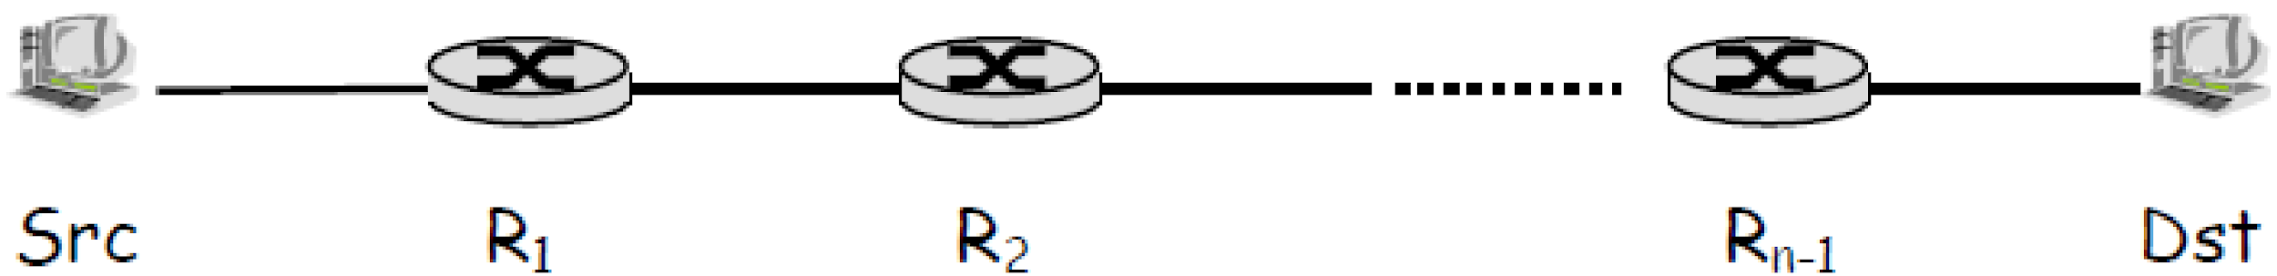

Assume that all links have the same length d and that the speed of light in the link medium is s. Assume that each link has bandwidth R and that packets of length L bits are sent through the network. Each switch can start forwarding the packet after Lc bits have been received.

1. What is the total latency for a single packet (counted from first bit sent at Src until last bit received at Dst)?

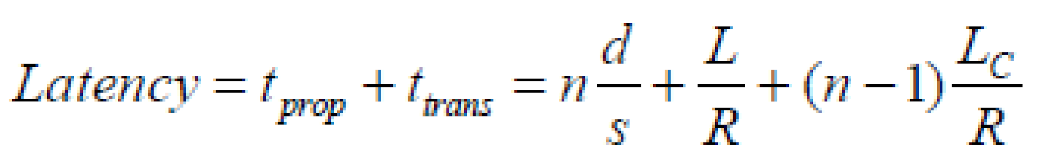

1. how much did cut-through switching reduce the latency for sending a single packet end-to-end, compared to store-and-forward?

Store and forward would mean that *LC* = *L*, so the savings are

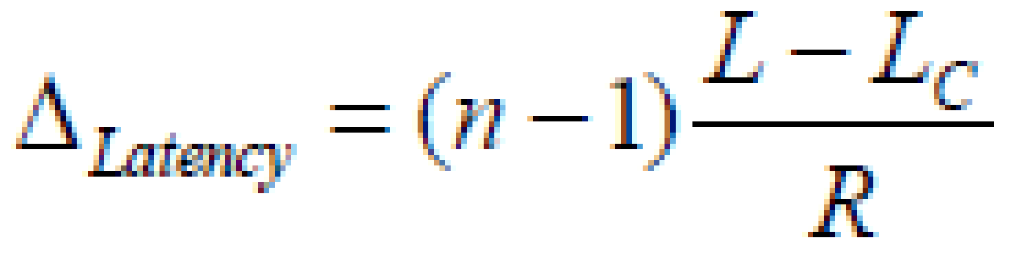

1. Now suppose a message of F bits is sent, which is sent as multiple packets. Will the latency savings increase, decrease, or stay the same as in the case of a single packet? Justify your answer.

The savings would be the same, because after the first bit of the first packet arrives, the remaining bits will in both cases arrive after F/R seconds (ignoring headers), because the source and all routers will be continuously operating.

[ If you include headers, it will take longer – but the transmission delay would be increased in both cases by the same amount, but you’d need those headers no matter whether the switches operate using cut-through or not.]

Exercise 08: